1: Eco-Conscious Shivani

Demographics:

* Age: 25
* Gender: Female
* Location: Urban Pune
* Education: Bachelor's degree in Electronics and Communication Engineering
* Occupation: Embedded system engineer
* Income: Middle-class

Challenges:

* Struggles to adapt to sustainable and eco-friendly way of lifestyle in her urban lifestyle.
* Wants to reduce her carbon footprint but faces challenges of not hitting the target.
* A curious minded earthling, always seeks information on sustainable living, eco-friendly practices, and climate change solutions.

Goals:

* Reduce her environmental impact and live a more sustainable lifestyle.
* To stay informed about the latest environmental and sustainability trends and innovations and implement them in her life.
* Find practical tips and advice on eco-friendly products, ethical brands, and eco-conscious lifestyle choices .

Why She Should Read Your Blog: Eco-Conscious Shivani should read my blog because it provides her with valuable information and solutions to her daily sustainability challenges. My blogs offer practical tips on eco-friendly living, and up-to-date news on environmental issues, helping her achieve her goal of reducing her carbon footprint and living a more sustainable life.

Buyer Persona 2: Sustainable master Vivek

Demographics:

* Age: 27
* Gender: Male
* Location: Pune
* Education: Master's degree in Sustainable Development and Environmental Engineering
* Occupation: Environmental consultant
* Income: Upper-middle class

Challenges:

* Faces difficulty staying updated with the rapidly evolving environmental technologies and practices.
* Seeks in-depth knowledge and expert insights on sustainability, conservation, and green solutions for which he can adapt in his daily life.

Goals:

* Continuously improve his knowledge and skills in the field of environmental sustainability so that he creates awareness.
* Stay informed about the latest developments in green technologies and practices which is necessary according to him.
* Connect with like-minded professionals and individuals who share his passion for sustainability like arranging plogging drives across the city.

Why He Should Read Your Blog: Sustainable master Vivek should read my blogs because they cater to his need for advanced information and expertise in the field of sustainability. My blogs provide in-depth articles helping him stay at the forefront of environmental advancements and connect with a community that shares his passion for a greener world and better world.

**An Email Marketing plan:**

Following are the screenshots of emailers which I sent to some of my subscribers:

1)Title of the Blog: How to reduce my Carbon Footprint?

Emailer:-

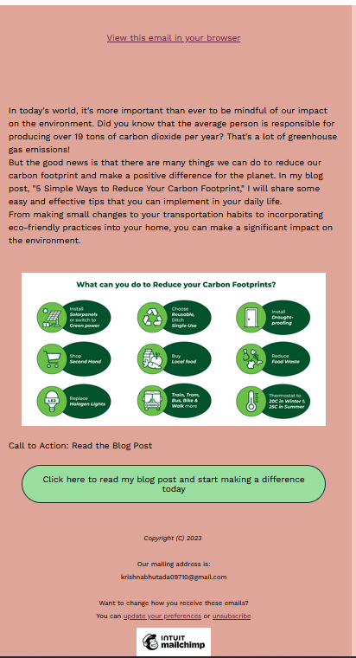

**Its Analytics data**:

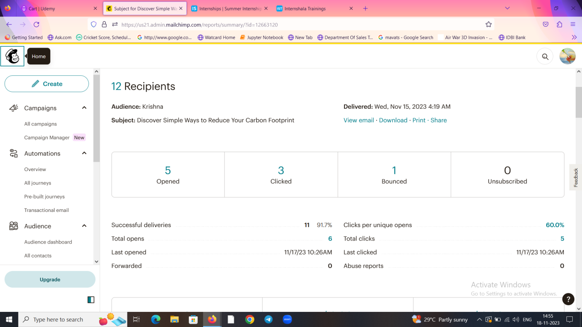

1)Open Rate: It is defined as a rate at which the no of mails sent to the total no of mails sent.

Here,it comes out to be 6/12=50%

2)Click Through Rate: It is calculated by the number of clicks clicked by subscribers divided by total no of emails sent . Here it comes out of 3/11=28%

3)Bounce Rate: The bounce rate refers to the percentage of emails sent that were returned undelivered to you as the sender to the total no of mails sent.

Here it comes out to be:1/12=8.3%

2)Title of the Blog:EcoBricks

Emailer:

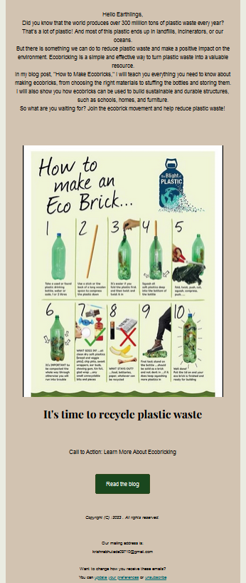

**Its** **Analytics data**:

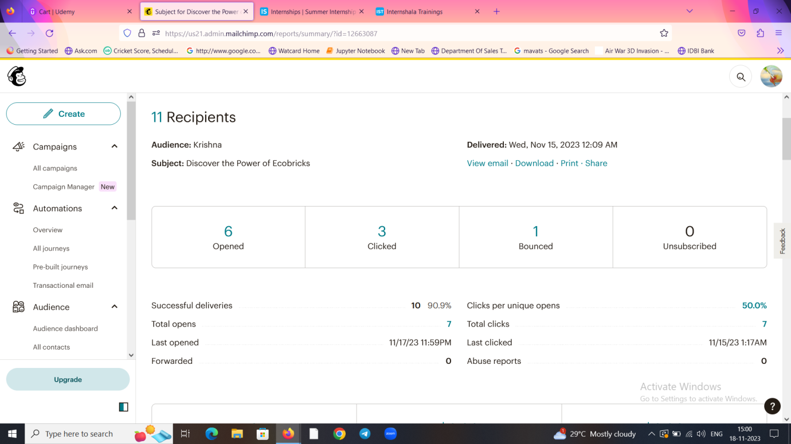

1)Open Rate: It is defined as a rate in which the no of mails sent to the total no of mails sent.

Here, it comes out to be 7/11=64%

2)Click Through Rate: : It is calculated by the number of clicks clicked by subscribers divided by total no of emails successfully delivered.This metric is called the click-through rate (CTR). Here it comes out of 3/10=30%

3)Bounce Rate: The bounce rate refers to the percentage of emails sent that were returned undelivered to you as the sender to the total no of mails sent= 1/11=9%

Title of the Blog: Impact of climate change on Developing economies

Emailer-: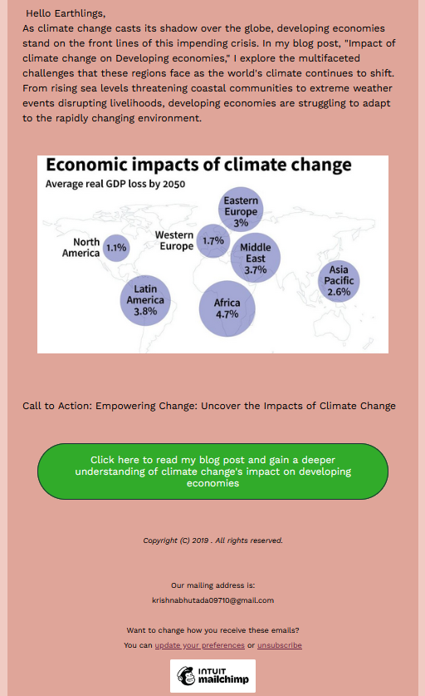

**Its Analytics Part:**

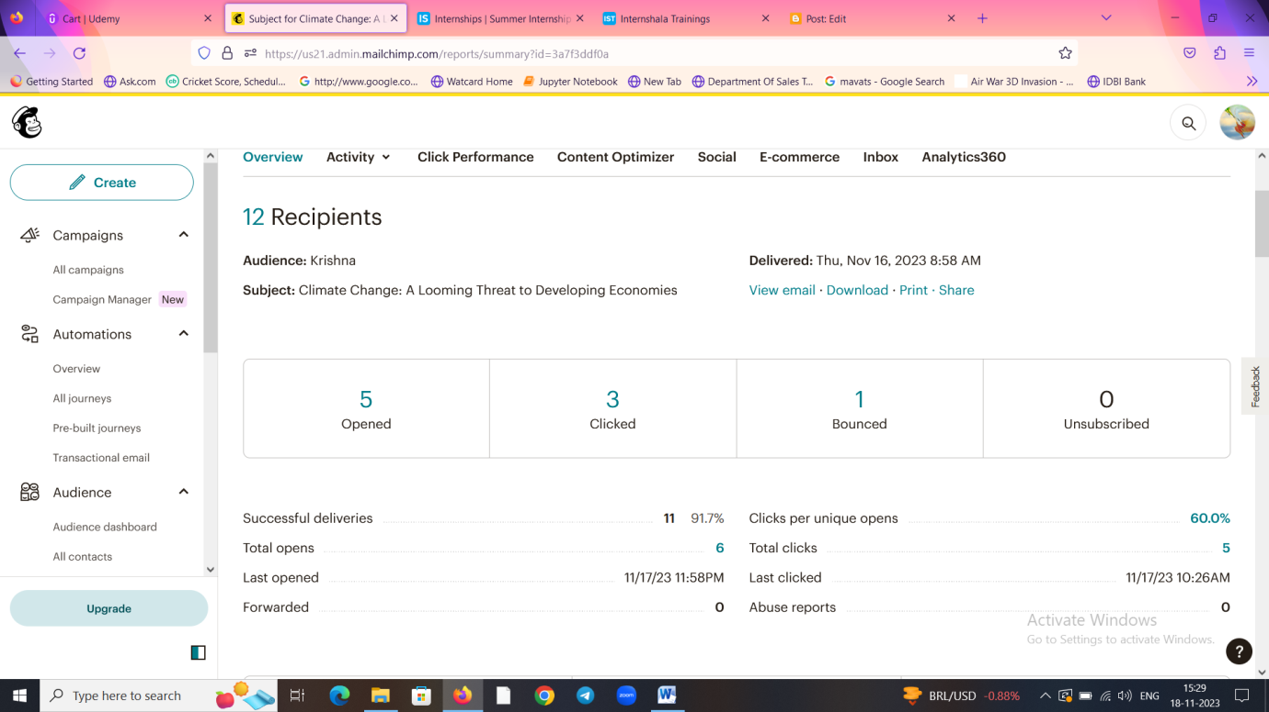

1)Open Rate: It is defined as a rate in which the no of mails sent to the total no of mails sent.

Here,it comes out to be 6/12=50%

2)Click Through Rate: It is calculated by the number of clicks clicked by subscribers divided by total no of emails successfully delivered. This metric is called the click-through rate (CTR). Here it comes out of 3/11=27%

3)Bounce Rate: The bounce rate refers to the percentage of emails sent that were returned undelivered to you as the sender to the total no mails sent.

Here it comes out to be:1/12=8.3%

**Conclusion:**

**Considering all the blogs and its subsequent data, I have found that almost all the blogs have received equal responses but by far the good response which I received is from the blog name: EcoBricks. I also promoted using word of mouth marketing insisting my subscribers to open and read the blog as its paramount importance.**